Sistemas Informáticos (Computer Systems)  
Unit 01. Activities 02 - Solution

short line

Authors: Sergi García, Alfredo Oltra

Updated September 2023

Unit 01. Activities 02 - Solution

# Exercise 01 - Solution

**Memory state:**

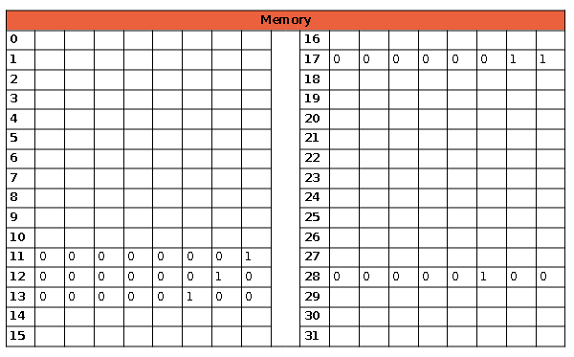

**Register state:**

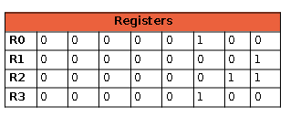

**Instructions explanation:**

**00001011** Write in memory position 11

(A) [01010101] Write 1

**00001100** Write in memory position 12

(B) [00100001] Write 2

**00010001** Write in memory position 17

(C) [00000010] Write 3

**00011100** Write in memory position 28

(D) [00101101] Write 4

**01001011** Copy the data from memory position 11 to register 0

**10000100** Copy the data from Register 0 to Register_1: 1 → in R1

**01011100** Copy the data from memory position 28 to register 0

**10001100** Copy the data from Register 0 to Register_3: 4 → in R3

**01010001** Copy the data from memory position 17 to register 0

**10001000** Copy the data from Register 0 to Register_2: 3 → in R2

**10111110** Multiply the content of R3 and R2 and write the result in R3 [3*4] → 12 in R3

**10101101** Subtract the content of R3 and R1 and write the result in R3 [12‐1] → 11 in R3

**01001100** Copy the data from memory position 12 to Register_0

**10001000** Copy the data from Register 0 to Register_2: 2 → in R2

**10011110** Add the content of R3 and R2 and write the result in R3 [2 + 11] → 13 ¡n R3

**01010001** Copy the data from memory position 17 to Register_0

**10001000** Copy the data from register_0 to register_2 → 3 in R2

**11001110** Divide the content of R3 by R2 and write in R3 [13/3] 4 in R3

**10000011** Copy the date from R3 to R0 → 4 in R0

**01101101** Write in memory position 13 the content of Register 0

**00101101** Show in the screen the content of memory position 13

**Solution to questions:**

1. Formula: ((D*C)‐A+B)/C.
2. 4 (Content of memory position 13).
3. The state shown in the solution.
4. If the PC was initially at 258, and we have executed 21 instructions, the PC will contain the value 279.
5. We have two bits, i.e. 4 registers.